ELID 530
Wk#8 – Final Project: Summative Assessment
Debbie Vogel

Introduction
The course I will use for my final project is called REDCap Reward Tracker. This is a course I built with content from one of my SME with the purpose of training site staff on using an electronic tool to record patient visits, drug screen results, and incentives. The overall outcome of the course is to provide step-by-step instructions using the tool to ensure fidelity to the Contingency Management model (previous training on the model provided in the first phase of training to the same learners), how to modify the records to fit site specifics, and troubleshooting log-in difficulties that often arise in the beginning. The learning objectives are as follows:
- Understand and troubleshoot REDCap Reward Tracker access
- Demonstrate recording attendance and UDT results
- Identify features and function so the REDCap Reward Tracker that enhance the delivery of high quality CM.
The course is created as an eLearning experience with three case study assignments. After completion of the course, the learners attend monthly Coaching Calls (virtual small group implementation training) to work through processes and systems for the CM Program at their site.
Assessment Techniques
I have created a matching activity for a formative assessment after the first course regarding Log-in Troubleshooting Tips. This activity was created in the LMS and is not graded. We decided to perform a formative assessment at this early stage in the course as it tends to be an area that needs extra attention for new learners to the tool.
I also created an assessment checklist for the three case studies the learners are required to complete at the end of the course. A checklist format was selected because the knowledge is procedural and the case studies provide the information the learner needs to complete a CM visit in the REDCap Reward Tracker tool. We have setup a practice project in REDCap for the learners to complete these three case studies in the actual tool. The assessment is quantitative data giving the learner 1 point for every correct entry, 0 points for missing entries. We did include a Notes section on the Assessment Checklist for feedback the instructor may want to provide along with their scores. The instructor of the course will be completing the Assessment Checklist grading and response to learners.
Assessment Tools
I am unable to send a url for the Knowledge Check as it is built within our LMS. Here is a screenshot of the activity:
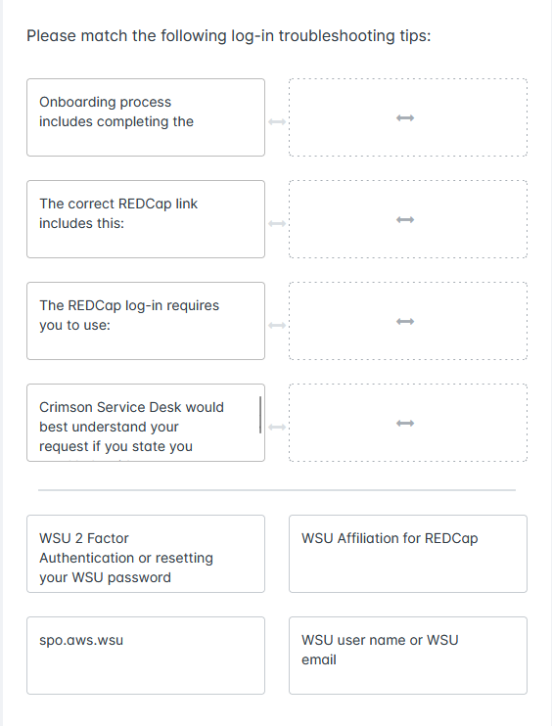

The case study assignments are also built in a software platform called REDCap, that I cannot give a url link to; however, the Assessment Checklist for grading the case studies has been uploaded to this assignment submission.
Evaluation
The variables used to show the assessments can prove achieved outcomes will be based on the following data:
- Number of students enrolled in the course
- Number of students passing the Knowledge Check in the given attempts. We can run a report at any time to evaluate learners completion and status on the Knowledge Check. We have our learners message us through the LMS or direct email regarding tech issues logging in to the REDCap tool. The desired outcomes for this course and the Knowledge Check means we will see a decrease in tech support emails and phones calls from our learners. We also hold monthly coaching calls where this topic and/or questions will come up. The Coaching Calls have minutes recorded and we would be able to track the occurrence of tech support inquired at these meetings. By collecting the data from both the Knowledge Check, tech support emails, and conversations in the monthly calls we can track challenges, improved results in desired outcomes, and track any areas that occur more frequently where we can focus improving our training.
- The Case Studies – Assessment Checklist will be objective data regarding the learner outcomes following the step by step instructions in the training prior to the assignment that they must follow in the assignments in order to obtain a passing score. The instructor will be completing the assessments and she is still trying to decide what the passing score should be as the monthly coaching calls are also used as a support system for the learners to continue to learn and customize the software tool for their site. The data from the learners’ assessments will be very useful in driving the training focus for the monthly coaching calls based on the outcomes of the assessment. Again, because there are three case studies and the assessment checklist is the same (except for some variables in entry fields) for all three case studies, it should provide the learner with some real world scenarios and opportunities to walk through the steps entering data in the REDCap tool.

