Name:
Teacher:
Class Period:
Date:

In this activity you will be looking at changes in the amount of carbon dioxide (CO₂) in Earth’s atmosphere. Then you’ll think about the ways in which humans are changing the concentration of CO₂ in the atmosphere through burning fossil fuels.

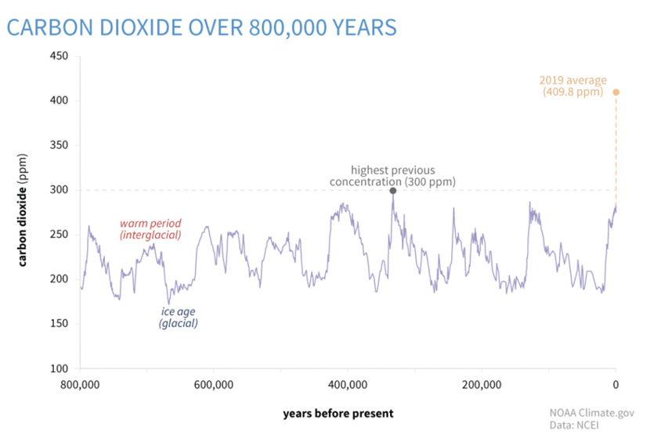

1. What patterns do you see in terms of the amount of CO₂ changing in the Earth’s atmosphere over the greater history of the Earth? How does the present (2019) amount of CO₂ compare to the rest of the timeline?

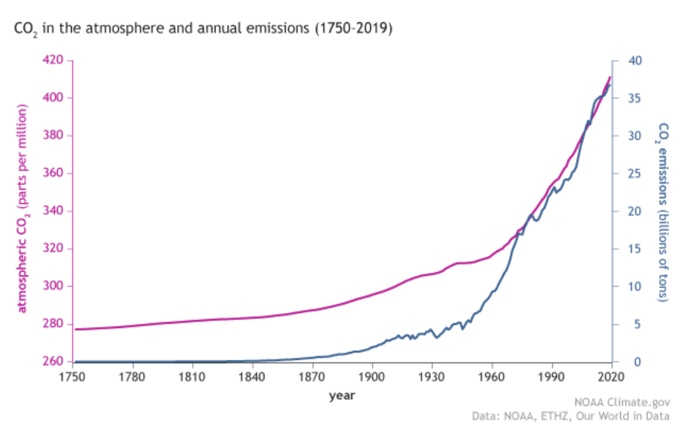

2. Take a look at this graph. Based on the axes, what story is this graph telling you? What are some specific ways that humans are causing the blue line on the graph to increase? What are things everyone can do to help keep the blue line from increasing so much?

What increases emissions (burns fossil fuels)? | What are ways we can decrease our emissions?

3. Think back to the greenhouse effect. What does it do and why do we need it? What do you think increasing emissions (adding more greenhouse gases to the atmosphere) could do to the greenhouse effect? What consequences might occur from this change?

Figures from: Lindsey, Rebecca. (2020). Climate Change: Atmospheric Carbon Dioxide. From the National Ocean and Atmospheric Administration (https://www.climate.gov/news-features/understanding-climate/climate-change-atmospheric-carbon-dioxide)

