Names:
Teacher:
Class Period:
Date:

Part 1: Photosynthesis review

The question we are answering: What are the inputs and outputs of photosynthesis in terrestrial plants?
Directions:
- As a group, review what the possible inputs and outputs of photosynthesis are based on prior knowledge and the class discussion.
- Fill in the boxes with your group's guess for where each input and output belongs. Illustrate these concepts with diagrams or drawings if that helps explain your thinking.

4.

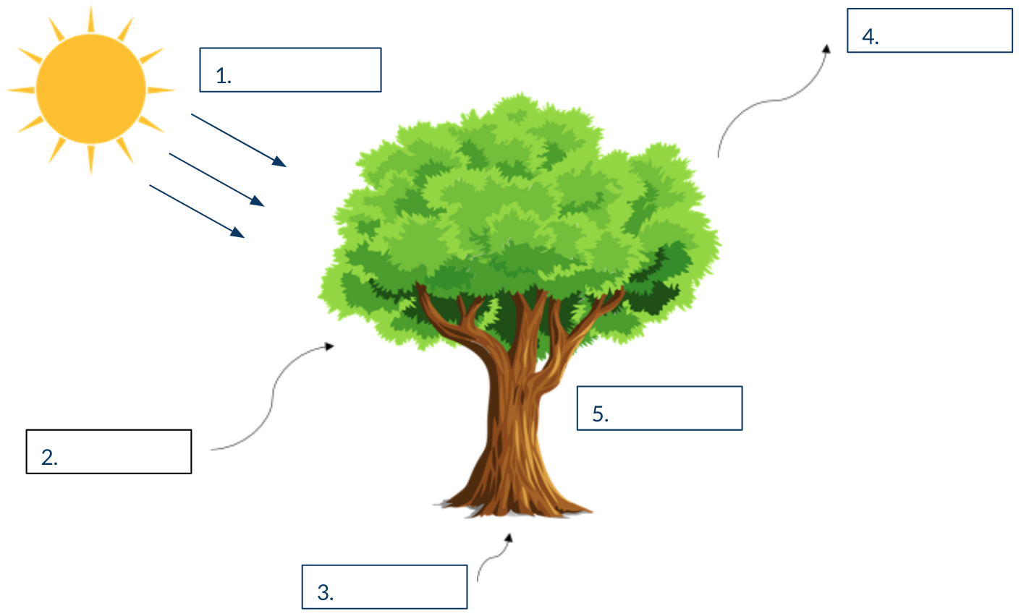

Part 2: Compare and contrast

The question we are answering: What are the similarities and differences between eelgrass and terrestrial plants in terms of photosynthesis? Where are the effects of photosynthesis felt?

Directions:
- For each side of the diagram, fill in how the inputs and outputs differ for terrestrial plants and ocean plants. In the middle, indicate how they are the same.

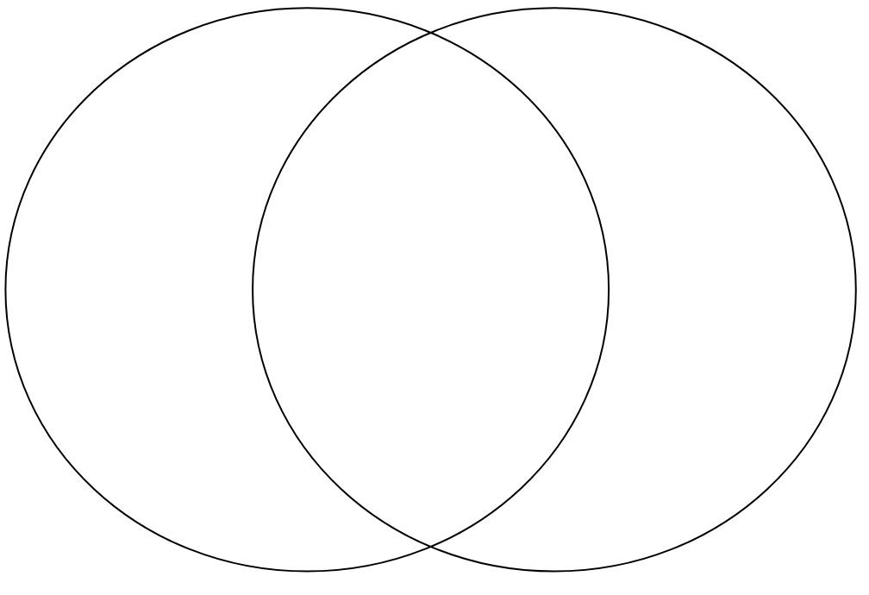

Exit question:
The ocean absorbs CO2 from the atmosphere. As CO2 concentrations continue to rise, what role will photosynthesizing plants, like eelgrass, play?
Write down a few ideas as a group to answer this question:

