**Lesson 1: Seasonal Variability**

**(with notes for instructor)**

Your group will be assigned a station. Your goal will be to determine the climatology of your region and place your findings in the context of the global temperature patterns.

**I. Make predictions and evaluate your data:**

*At the top of your station excel data sheet, the latitude and longitude of the station is given. Locate your station on a map.*

**\*\*Note: Either a world map with clear latitude and longitude lines on it or Google maps is needed here. In Google maps, latitude and longitude can be entered directly (e.g. – Seattle would be entered as 47.6067 N, 122.3331 W)\*\***

Questions:

a) What city/country is your station located in?

**\*\* see ‘station_map.tif’ with station numbers and locations for answer key\*\***

b) Describe your station location: Include any information you think would be relevant to the local climate including latitude, distance to nearest ocean, east coast verses west coast, and elevation. Is your station in the tropics, subtropics, mid-latitude, or high-latitudes? Is it in a convergent or divergent zone?

**\*\*Each student’s answer will be different, and answers will vary depending on what has already been covered in class. Students should touch on the effect of latitude, altitude, and proximity to coast on weather. They could include information about precipitation as well as temperature. \*\***

c) For your station, when is summer? When is winter? What would you expect the variation in temperature between summer and winter to be?

**\*\* If the station is in the northern hemisphere then summer/winter is in July/January and opposite in southern hemisphere. The further poleward a station is the larger the seasonal cycle. The students should be able to explain why. \*\***

d) How long is your time series? Is it continuous? Are there any missing data? How will this affect your analysis?

**\*\* This varies by station\*\***

**II. Variability**

*The data is given in a matrix, with the columns from left to right containing; station number, country code, year, and January-December monthly mean temperature. Therefore, if you wanted a continuous time series of temperature, you would progress from left to right moving down the rows, as if you were reading a book. Where data is missing, ‘NaN’ appears.*

*Choose a single month. Plot at least 20 years of that months mean temperature (with years on the x-axis and temperature on the y-axis)*

**\*\*Note: This section has the students first find the mean and standard deviation by hand to help them understand what excel is doing before simply having the computer do it for them. If you think students have an adequate understanding of mean and standard deviation, this section can be skipped. If students need a further help with these terms** [**http://www.mathsisfun.com/data/standard-deviation.html**](http://www.mathsisfun.com/data/standard-deviation.html) **has a good graphical explanations of standard deviation. It also has some good pictures that could be used in class prior to the lab to help explain these terms. \*\***

*From your plot, make predictions about what you think the mean, max, and min values are from your plot. The average plus/minus one standard deviation should contain 68% of the data. Approximately, what would you guess the standard deviation would be?*

Record your predicted:

Mean_________ Max_________ Min_________ Standard Deviation_________

*For the 20 points you selected, calculate the average and standard deviation using a calculator.*

*Mean: the mean () is the sum of all points (****X****) divided by the number of points (****N****). This can be written as:*



**\*\*Note: If the math equations make this more confusing, they can be left out. \*\***

Standard deviation (σ): The standard deviation gives how much the data varies from the mean. To calculate this, first subtract the mean calculated above for each of the data points (X). Square each difference. Sum all these values and divide by the number of points. Finally take the square root. This can be written as:



Record the mean and standard deviation:

Mean ____________________ Standard Deviation __________________

*Now calculate it again using excel.*

Record the mean and standard deviation found by excel:

Mean ____________________ Standard Deviation __________________

Label the axis on your figure. Save and print.

**\*\*Note: Since answers to this will depend on which 20 years of data the students pick, make sure they show their work so you don’t have to recalculate each station to evaluate.\*\***

Questions

a) How do your predicted and actual mean/standard deviations compare?

b) What would cause your standard deviation to increase? What would cause it to decrease? Support your answer with evidence from the graphs you have just made.

**III. Finding the climatology:**

**\*\* Each version of Excel is a little different. Make sure you have figured out how to make x-y plots and calculate standard deviations and averages on the version of excel your students will be using prior to this lab. Teachers must change the instructions below to match your version of excel.\*\***

*Monthly mean: Label the bottom row following your last year “Monthly Average”. In the first cell calculate the average for all available data for that month using the AVERAGE function. Select the cell you just formatted and drag it across all the columns. This should calculate the average temperature for each month in your excel sheet.*

*Label the next row standard deviation. Use the STDEV function and calculate the standard deviation for each month.*

*Make a line plot of the average monthly temperature verses month. Add error bars of one standard deviation to your figure (select the data points on the graph, select Format -->Data Series from the draw down menu, select error bar from the left-hand column. Choose y-error bars, then select ‘custom’. Highlight the standard deviation row from your worksheet).*

*Finish your figure by adding axes labels (including units). Print your figure.*

Questions:

a) When is summer? When is winter? What is the seasonal variation in temperature? Were your predictions correct? Comment.

b) What are the mean summer, winter, fall, and spring temperatures for your region?

c) How big are your error bars compared to your mean seasonal cycle? What would this mean for someone living in this region? What would be the chances of having a “summer like” day in the middle of the winter at your station?” Refer to your data to support your answer.

**VI. Regional variations**

*Pin your printed plots up next to the map and attach a string from the plots to your station location.*

*Use the class results to answer the following questions:*

Questions:

a) How does mean temperature vary by latitude? What do you think causes this variation?

b) How does temperature vary by longitude? Pick two stations at roughly the same latitude but different sides of an ocean, how do their mean temperatures differ? List two factors that might explain the temperature difference.

c) Where is the range of temperature experienced in a given year greatest? Where is it the least? Why do you think this is so?

**Lesson 2: Local and Global Historical Trends**

**(with teacher’s notes)**

Your goal will be to find temperature trends at your station over the past 100 years. The class will bring their findings together to examine spatial variability in station trends. Finally, you will use global mean temperature data to calculate climate change.

**I. Trends, Smoothing and Error**

**\*\*Again, each version of Excel is a little different. Make sure you have figured out how to make x-y plots and calculate standard deviations and averages on the version of excel your students will be using prior to this lab. Teachers must change the instructions below to match your version of excel.\*\***

*Open the temperature data in excel. The data is given in a matrix, with the columns from left to right containing year, and January-December monthly mean temperatures. Where data is missing ‘NaN’ appears. Temperature data is given in °C.*

*Fill in any missing data with that mouths mean climatology value found in lab 1.*

**\*\*Teachers – ask the students why we replace NaNs with the climatological mean, what else could they do? What would happen if they made the missing data zero? Or left it out?\*\***

*Annual Means: Label the column following December “Annual Average”. In the first cell under that calculate the average for all available data for that year using the AVERAGE function. Select the cell you just formatted and drag it to the bottom of the column. This should calculate the annual average for each year*

*Now find the mean of the annual means for your station by finding the average of the Annual average for all years.*

*Anomaly: Label the next free column “Anomaly”. An anomaly is the difference from the mean. For each year, calculate the anomaly by setting it equal to the Annual Mean minus the total mean.*

**\*\* (e.g. the first cell would be ‘=P4-AVERAGE(P4:$P$113)” the $ symbol holds the value constant when you drag it down the column).\*\***

*Plot the anomaly column verse year using a scatter plot. Label the x and y axis.*

Questions

Make some observations about your data set. Do you think you have a trend? If so, what would you guess the slope of the trend is? Does it appear to begin/end at a certain point in time?

Linear Trends:

*Add a trend line: Select a data point on your graph. Right click so the drop- down menu appears. Select “Add Trendline”. Under type, select “linear”. Under “options” select “display equation on chart”.*

*On the same plot, re-plot the anomaly verse year but only for post 1960 data. Add a second trend line to this data and again display the line equation of the figure. Change the trend line to a different color then used previously.*

Running mean

**\*\*this is additional if your class has time. Running means are often used by scientist to smooth out the data. See IPCC report.\*\***

*Running mean: Label the next free column “5 Year Running Mean”. In this column, skip down to the third year with data. Make this cell equal the average from two years prior to two years after (e.g. ‘=AVERAGE(R4-R9)’). Select this cell and drag it down to the bottom. This is called a 5-year running mean.*

*Plot the 5-year running mean in a different color then your data using a line plot. Add a trend line for the 5-year running mean data.*

*Make and label a legend and make sure all axes are labeled. Print your figure.*

*Now that you know how to plot data and find trends, make a new plot of mean summer temperature (e.g. Northern Hemisphere – Jun, July, Aug) and mean winter and find the trend.*

Questions

**\*\*The plots for each of the 18 stations with the answer students should get are in the “teachers_figure” folder.\*\***

a) Calculate the trend over different time periods. Can you find periods with a negative trend? Periods of positive trend?

b) What was your overall trend? This number will be in °C/year. What is the trend in °C/decade? °C/century?

c) Why did we fill in missing data with the mean and not simply find the mean for less than 12 months of data?

d) How does the smoothed trend compare to your unsmoothed trend? What would be the advantage of using the smoothed data?

e) How does the summer/winter trend compare to the overall trend? Why do you think scientists would be interested in seasonal trends as well as annual trends?

**II. Regional Trend**

*Pin your printed plots up next to the map and attach a string from the plots to you station location.*

Questions

a) Which regions warmed/cooled the most?

b) What is the highest warming found? What is the largest cooling found? How does this compare to the global average?

c) Compare the class findings to the finding by the IPCC report below. How do they compare? Why would there be differences?

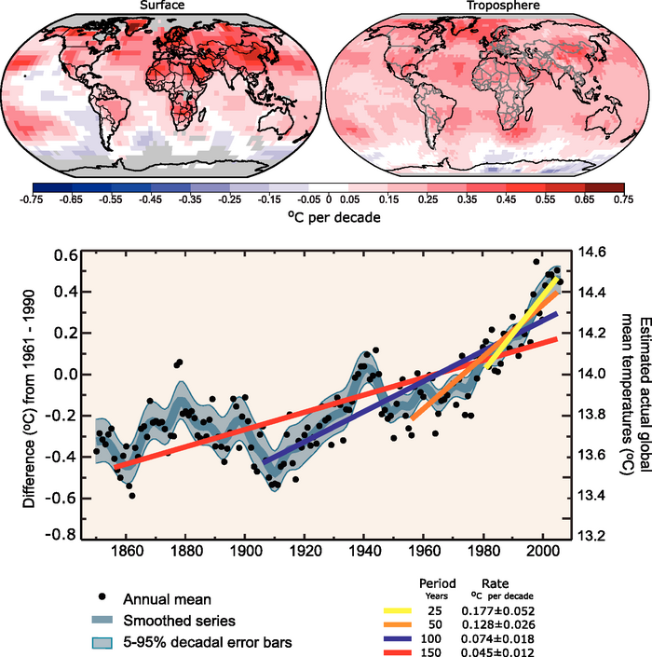

**III. Global trend**

*Open the global data. This data is formatted the same way your station data was formatted but is now the temperature mean for the whole globe.*

*Again, calculate the annual mean anomaly and a 5-year running mean smoothed annual mean.*

*Plot the anomaly and the smoothed data verse time. Find the trend for 1900-2010, 1960-2010, 1980-2010 and the smoothed data.*

*Adjust and label axis and make a legend. Print figure.*

Questions

a) How does the global mean compare to your station? Did you have a stronger or weaker trend? Was there more or less variability?

b) Why is it important to look at the global mean? Why is it also important to look at regional differences?

c) Why is it important to look at multiple temperature records? Why do we look at averages?

**Lesson 3: Climate Model Predictions and Local Impacts**

**(with teacher’s notes)**

Your goal will be to find the temperature trend at your station over the next 100 years using model output. Then you will use your findings to predict the implications of climate change for your region.

**\*\* This data is in the “station data” folder\*\***

**\*\* If the students have completed lab 1+2, they should be able to navigate excel at this point to complete this lab.\*\***

**I. Trend**

*Your station data is given in two columns, year and annual mean temperature.*

*Find the mean temperature for the next 100 years.*

*Anomaly: Label the next free column “Anomaly”. For each year, calculate the anomaly by setting it equal to the Annual Mean minus the total mean.*

*Plot the anomaly column verse year using a scatter plot. Label the x and y axis.*

Question:

Make some observations about your data set. Do you think you have a trend? Does it appear to begin/end at a certain point in time? Do you think your trend is linear?

*Add a trend line: Select a data point on your graph. Right click so the drop-down menu appears. Select “Add Trend line”. Under type, select “linear”. Under “options” select “display equation on chart”.*

*Print your figure.*

Question:

a) Does this model data predict your station will see a significant change in temperature over the next 100 years? What is your overall trend?

b) This data was generated by a single model. Do you trust your results? How could you make these results more robust?

**II. Report summary**

*Your teacher will provide you with a copy of the IPCC AR4 chapter 11. The chapter is subdivided into continents. Read the section on the continent your station is located. Write up a summary of the changes your continent is likely to experience in two parts. Part one should focus on a summary of the predicted changes. This can mostly be found in your assigned reading from the IPCC report. Part two should focus on how you think these changes will affect the communities living in these regions and additional research may be required.*

**\*\* Note: This part of the lab is left very open ended. Teachers may want to add instruction to this to specify expectations for the report. These could be done as a longer, more in depth homework assignment, or a shorter group in-class activity. It could also be an oral report given by groups to the class instead of an individual written assignment. \*\***

*Part I: Be sure to include answers to the following in your report:*

a) What are the overall trends for the continent? Include both temperature and precipitation.

b) Are the different GCM models fairly consistent between each other? How do these predictions compare to what you found at your single station?

c) How will climate change likely affect different regions of your continent? What are the regional trends in temperature and precipitation? Is there a large variation?

*Part II: Additional research on your country may be needed. You do not need to address all these questions, there are just suggestions for possible topics to be researched. Based on your regions you may research whatever you find most interesting.*

d) If you were the present of a country in your region, what would you think was the number one concern for the future?

e) How will the trends in temperature and precipitation affect agriculture? What will this mean for the country?

f) What it the political and economic status of the countries in your region? Do you think climate change will dramatically affect the countries economically?

g) What are the countries water resources? How will these possibly change in the future?

h) What is the regional sea level rise predictions for your region? How will this affect the countries in your region?