Name:______________________
Teacher:_____________________
Class Period:_________________
Date:_______________________

The question we are answering: What processes caused the 2015 closure of razor clam fisheries in Washington?
Directions:
- In each phase (before the bloom, during the bloom) draw and label what you can see and what processes are going on to connect the temperature, algae, and clams. Add in other things as needed to connect these things, and make sure to try to write, draw, or otherwise represent things that are happening but unobservable.
- Remember there are many ways of representing things, so feel free to be creative, but we need to be able to understand one another's models, so add a key if needed.

Before the Bloom: During the Bloom:
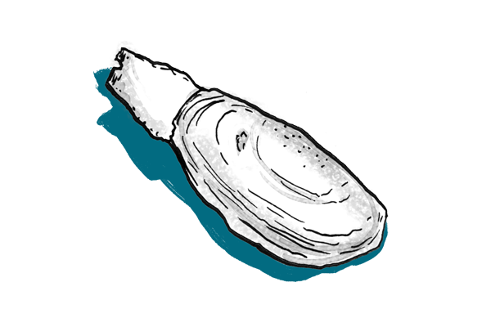 | 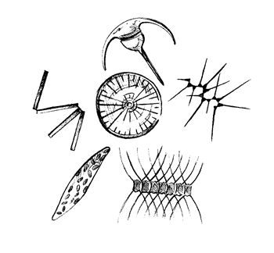

Puzzle Box: What questions are puzzling you about this? What would you like to know to improve your model for next time?

Names:  Ingredients: Sun Only  Bloom Hypothesis: | Names:  Ingredients: Nutrients Only  Bloom Hypothesis:
Names:  Ingredients: Sun and Nutrients  Bloom Hypothesis: | Names:  Ingredients: Nothing  Bloom Hypothesis:

Name:______________________
Teacher:_____________________
Class Period:_________________
Date:_______________________

Exit Slip
(please complete this worksheet before class ends)

- During class activities and group discussion today, which of the following did you try? (Check all that apply)
- I shared my ideas
- I listened to my partners’ ideas
- I agreed with my partners’ ideas
- I disagreed with my partners’ ideas
- I used scientific evidence to support my idea
- I asked a clarifying questions
- I could revoice my partners’ ideas
- My partners and I looked for similarities and differences in our ideas

- Explain one thing that you understand better or differently after talking with your partners today.

