Name:______________________
Teacher:_____________________
Class Period:_________________
Date:_______________________

Entrance Slip
(please complete this worksheet before class stars)

Look at the bloom experiment we set up on day 1. Did any of the conditions grow an algae bloom? How can you tell? Which ones? Was anything about the bloom or lack of bloom surprising to you?

In class yesterday we studied different algae blooms around the world. What are some things that you think are important in determining whether or not a bloom happens?

What are some things that you think are important in determining whether a bloom is harmful or not?

Some Zooplankton you might see:
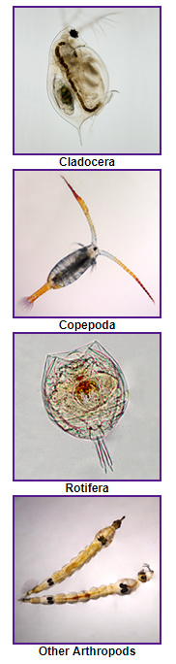

Cladocera (Approximately 1 mm long):

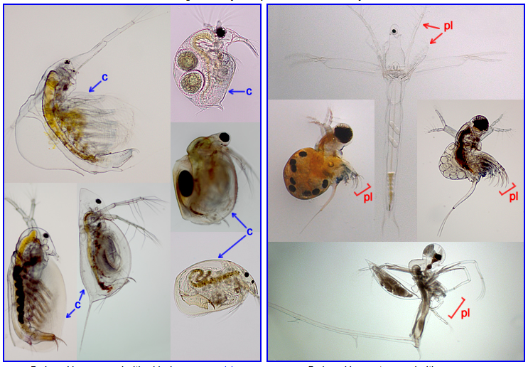

Copepod (Approximately 1-2 mm long):

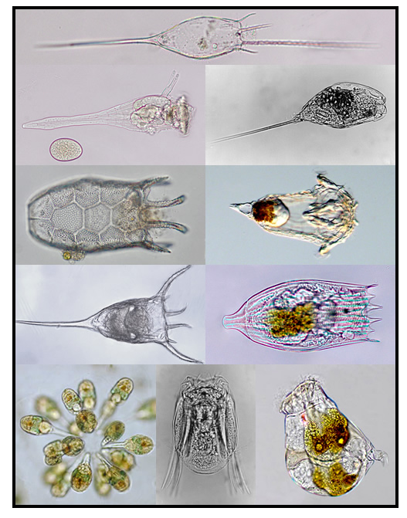

Rotifer (usually 0.1–0.5 mm, can be bigger):

Some phytoplankton you might see:

Centric diatoms (10s - 100s of μm): Pennate Diatoms (10 - 100s of μm,
can be in chains):
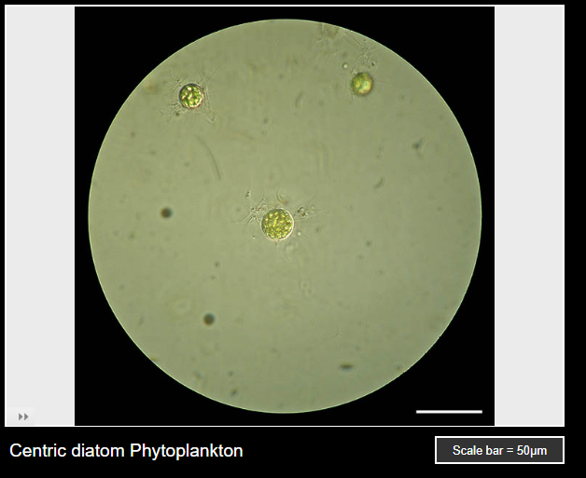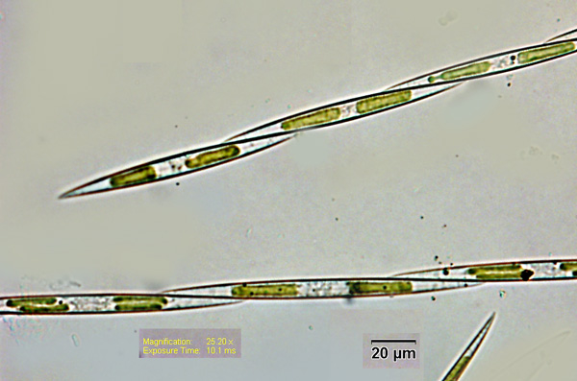
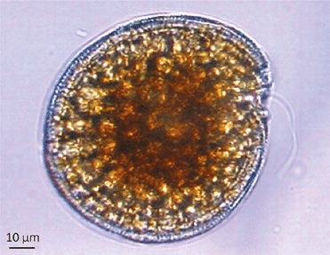
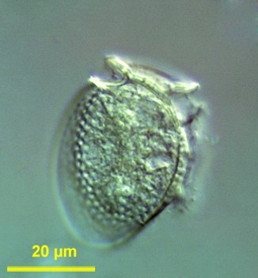
Dinoflagellates (10s of μm):
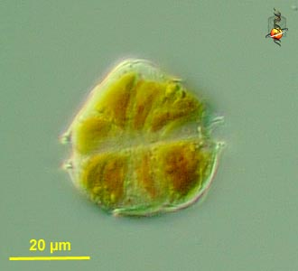

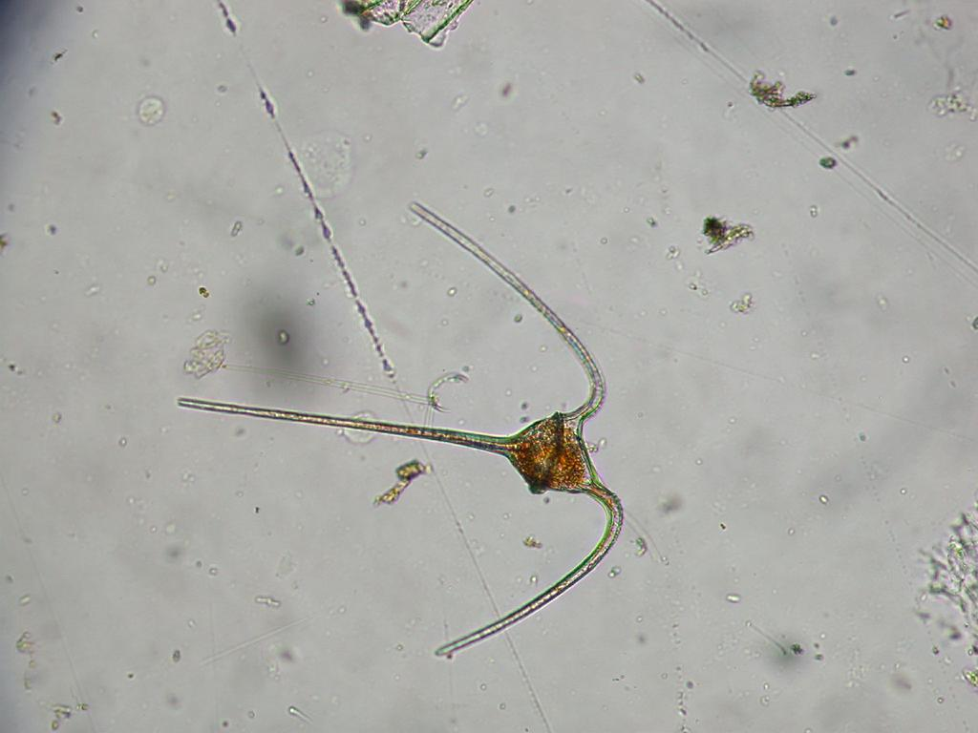

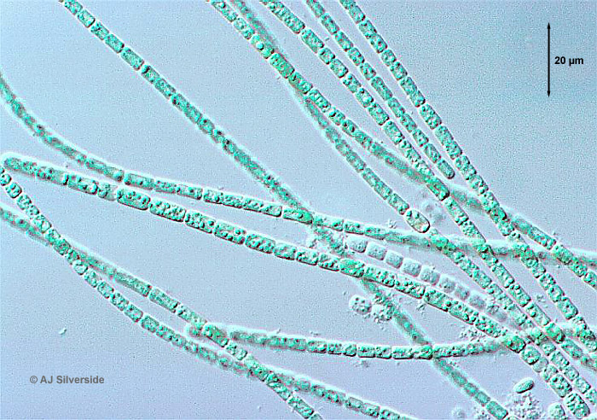
Blue-Green Algae (Cyanobacteria) (less than 10 μm, but can be in chains):
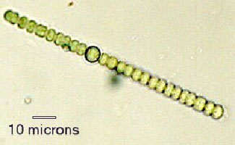
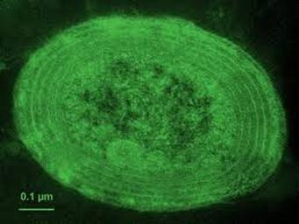
Plankton Microscope Lab:
In this activity you will explore the tiny watery world of plankton using only a piece of paper and a pencil. Sketches require scientists to focus on details and make keen observations that can be overlooked when taking a picture. It also allows them to detail particular areas or structures that are of interest.

Below is an image showing types of organisms in different size classes of plankton and the tools used to see them.
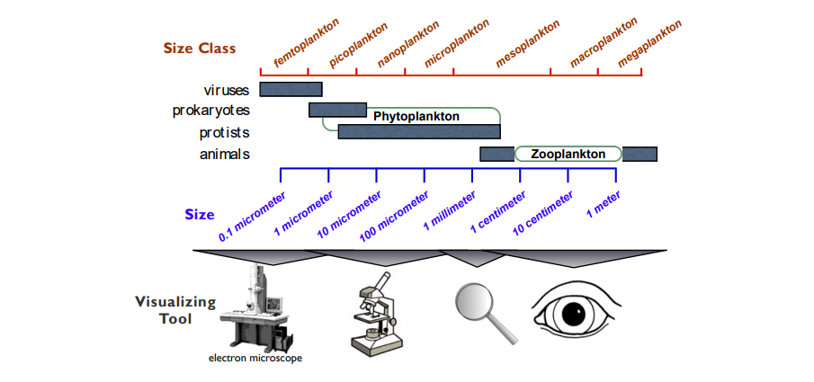

Today's activity:
Step 1: Find a partner to share a microscope with (there might need to be a few groups of three). One of you come to the front of the class get a slide for looking at plankton from the algae bloom experiment or the pond, the other come get a slide for looking at plankton from the Puget Sound or Portage Bay.

Step 2: Each partner takes 1 minute to look through the microscope at the samples and try to find a few interesting organisms.

Step 3: Each partner takes 1 minute to count as many different organisms as you can see. The other partner keep time. You should count different samples.
Record your numbers on the board.
(Continues on other side if you have time)

Step 4: Pick an organism to sketch from samples or from the images in the ID guide. Think about the following questions. What shape is it? Is it one organism, or many? What color is it? Can I see any organs inside the body? How large is this organism?

Step 5: Before you start drawing think about how big you want to draw your organism. We want to be able to compare the sizes of different plankton. You will be sketching the plankton magnified and can use scale bars in your images to help others interpret your drawing.

Step 6: It is time to begin sketching! Below is a list of guidelines to follow.
- Don’t be intimidated.
- Pay close attention to detail and draw what you see.
- Start with the big stuff and then move on to fill in the details.
- Start sketching lightly. You can darken your drawing when you add the details.
- Don’t get frustrated, just do your best. Scientific sketching is a skill and you only get better at it if you practice!

Step 7: Compare with another microscope group to see if you had similar or different plankton in your samples.

Name:___________________________________ Teacher:_____________________________________ Period:__________________________________

The question we are answering: What processes caused the 2015 closure of razor clam fisheries in Washington?
Directions: 1. In each phase (before the bloom, during the bloom) draw and label what you can see and what processes are going on to connect the temperature, algae, and clams. Add in other organisms and processes as needed to connect these things, and make sure to try to write, draw, or otherwise represent things that are happening but unobservable.
2. Don't forget to include the concepts in the word bank on the board. Remember there are many ways of representing things, so feel free to be creative, but we need to be able to understand one another's models, so add a key if needed.

Before the Bloom: During the Bloom:
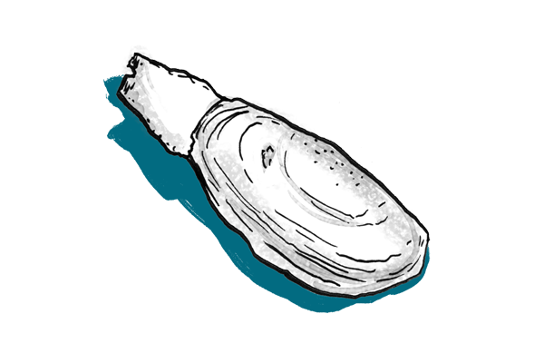 | 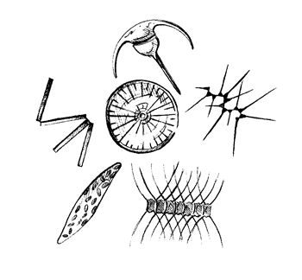

Directions: Now draw a new model based on what you think will happen in the future as our climate changes? Think about the ideas we discussed yesterday that are ingredients for a harmful algae bloom, and the impacts of climate change that might affect harmful algae blooms.

Impacts from climate change:

Write about what you think causes harmful algae blooms (Use evidence from a class activity or other experiences/knowledge you have to support one of your ideas):

What is some information you could collect during or before a harmful algae bloom to see if your understanding is correct?

How can people change their behavior to decrease harmful algae blooms or reduce the impacts of harmful algae blooms?

Name:______________________
Teacher:_____________________
Class Period:_________________
Date:_______________________

Exit Slip
(please complete this worksheet before class ends)

Answer the following questions by circling a single number for each:
- How included did you feel during the group work activities this week?
I did not feel included 1 2 3 4 5 I felt very included

- How much did you learn in the following activities?
Trace the Toxin
I did not learn much 1 2 3 4 5 I learned a lot

Groups reading and discussing about HABs yesterday
I did not learn much 1 2 3 4 5 I learned a lot

Plankton lab: Microscopes and scientific drawing
I did not learn much 1 2 3 4 5 I learned a lot

Drawing your models
I did not learn much 1 2 3 4 5 I learned a lot

- What was something you really enjoyed this week?

- Do you have any additional feedback?

