Name:______________________
Teacher:_____________________
Class Period:_________________
Date:_______________________

Entrance Slip
(please complete this worksheet before class stars)
What are the some examples of environmental conditions that can cause a harmful algal bloom?
________________________________________________________________________________________________________________________________________________________________________________________________________________________________________________________________________________________________________________
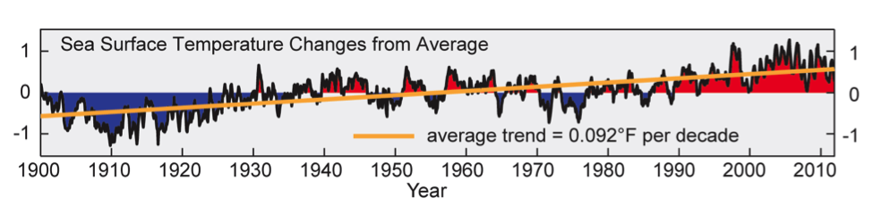
The figure above presents the sea surface temperature changes from average for the ocean surrounding the U.S. and its territories over the past century. What do you think is causing the change in average sea surface temperature? Do you think a similar trend is experienced in other oceans around the world?
________________________________________________________________________________________________________________________________________________________________________________________________________________________________________________________________________________________________________________
____________________________________________________________________________

How do you think the sea surface temperature change will impact harmful algal blooms?
________________________________________________________________________________________________________________________________________________________________________________________________________________________________________________________________________________________________________________
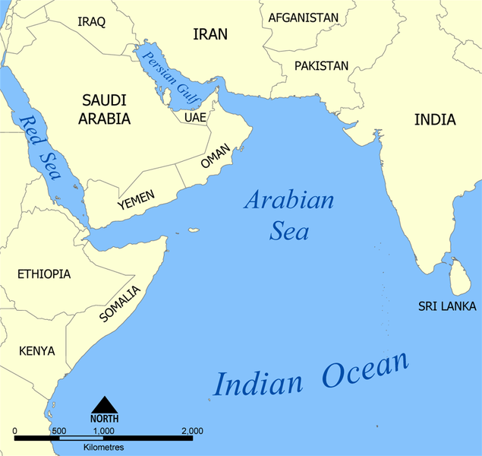
Arabian Sea Ongoing Bloom
Over the past decade, Harmful Algae Blooms (HABs) the frequency of harmful algal blooms in the Arabian Sea have increased dramatically.

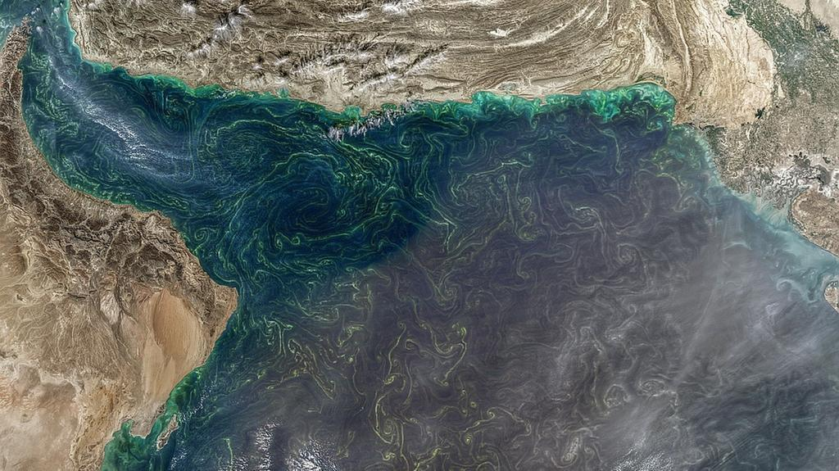
Ingredients: HABs in the Arabian Sea usually occur when there is high nutrient concentration. These nutrients can come from a variety of places:
- Dust: The Arabian Sea is generally surrounded by a very dusty region, with many sand storms. Dust contains a lot of iron, which can make phytoplankton grow faster, because many proteins need iron (We humans need iron too!).
- Water currents: When water is mixed up from the deep ocean it adds cold, nutritious water to the surface where phytoplankton grow.
Satellite images show an algal bloom (Jan 2018) in the Arabian Sea

- Human activities: Marshes, which normally trap pollutants, have dried out because of dams and other human caused landscape changes. Now more pollutants have made their way into the sea. Oil dumped into the Arabian Sea also changed the marine life. Desalination plants (factories that take salt out of seawater in order to make it safe for drinking) release hot and salty water that contains other chemicals like chlorine into the sea. Hot wastewater full of nutrients and pollutants is released from chemical plants and power plants.
Temperature also affects phytoplankton growth, but each phytoplankton species has a different optimal growth temperature. High temperatures typically increase growth rates until a ideal temperature is reached and then growth slows after that.

Effects: HABs in this area have had three main effects:
1) The death of lots of fish and shellfish in Kuwait (2001), Oman (2005), and UAE (2008).
2) Causing respiratory irritation in humans
3) Stopping the operation of desalination plants because of high toxicity level in the water surrounding the plants. These desalination plants are a major source of freshwater in the region.

In the news: Modified from The National (UAE), from May 14, 2018.
“Saadiyat Beach has been closed to swimmers after a harmful algal bloom was found in the sea surrounding the island. It is understood that the red tide — which is caused when a species of algae called dinoflagellates grow out of control — was discovered.

Dinoflagellates contain pigments that vary in colour from brown to red during the day — giving them their name “red tide”. There are thousands of species of dinoflagellates — and a few dozen can be extremely toxic to people and marine life. In 2008 and 2009, a red tide caused serious damage to the UAE’s marine life, damaging fish stocks, coral, and wiping out large populations of fish in Dibba Rock. Shark numbers in the bay are only now recovering.

A spokesperson from Saadiyat Rotana Resort and Villas said the Tourism Development and Investment Authority had instructed the beach area be temporarily closed until the red tide cleared. He said Environment Agency Abu Dhabi (EAD) took samples of the red tide on Saadiyat at the weekend. Tests are ongoing to establish the exact type of algae, but it is understood to be an irritant, rather than toxic. Residents on Saadiyat received an email on Sunday saying that the beach has been closed for swimming until further notice.

“It is confirmed by EAD that the red algae are not toxic, however, [they] can cause skin allergies. Further studies are still undergoing,” read the email. “Therefore, you are kindly requested to abide strictly by the recommendation of the EAD and refrain from swimming in the sea. We will keep you posted as to when the beach will be safe for swimming.”

Marine biologists say phytoplankton species are always around, but certain conditions enhance their growth. Red tides tend to occur more frequently as the temperature rises. This combined with the strong, dusty winds could be acting like a fertiliser, causing the algae to bloom, say scientists.

“If you have a lot of winds coming off the land it could be enhancing the amount of iron and allowing them [the algae] to bloom,” said John Burt, Associate Professor of Biology at NYU Abu Dhabi. “We have had winds for the past week coming off the land, so it is possible that we have this iron deposition going on that is enhancing things, along with the rising temperature. So when the winds turn around and start coming off of the sea again, we will see if it disappears or not. That would be a good indication of whether dust is involved.”

The Arabian Gulf is the hottest sea in the world, making it particularly susceptible to the phenomenon.”
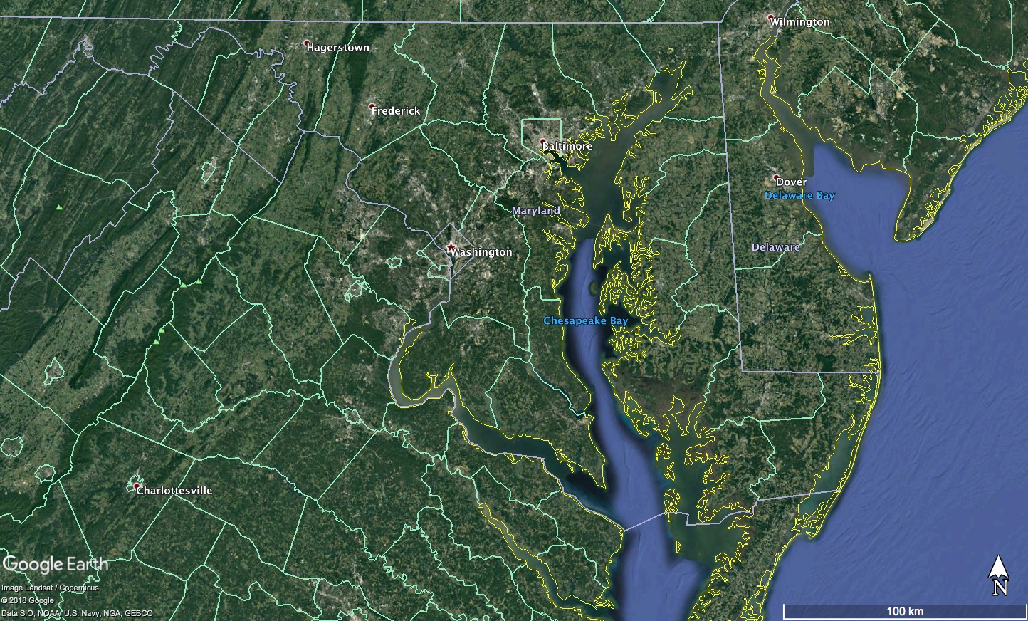
Chesapeake Bay
Disruptive HABs in the Chesapeake Bay have become more frequent in the last few decades.

Ingredients:
From 1991-2008, data provided by the Maryland Department of Natural Resources indicated large increases in the blooms of three contributing species to harmful algal blooms in the Chesapeake Bay: the dinoflagellate genera Prorocentrum and Kalrodinium as well as blue-green algae (cyanobacteria). Each of these organisms produce toxins and/or contribute to unfavorable water quality when abundant. The reported increase in blooms are in addition to observed, temperature-dependent blooms of these harmful species during the spring and summer. More blooms of Prorocentrum were found in late spring, while Kalrodinium blooms were more frequent in the summer months. Cyanobacteria blooms appeared to happen throughout the year. Over the same period, growing populations in the Baltimore-Washington, D.C. region may have contributed to excess nutrient runoff from land into Chesapeake Bay.

Effect:
The increases in bloom frequency from 1991-2008 has been implicated in fish-kill events in Chesapeake Bay as well as the failure of oyster spawning and development. Additionally, the decay of blooms by bacteria within the bottom sediments of the Bay consumes dissolved oxygen from the water and often results in seasonal “dead zones,” or areas which are so low in oxygen that neither fish nor any other animal can survive. As a result, there are growing concerns that the impacts of HABs will amplify into effects on food webs and energy cycling within the Chesapeake Bay.
The President of the University of Maryland Center for Environmental Science, Don Boesch, states “The increasing frequency and intensity of these harmful algae blooms will impact our ability to achieve the ultimate goal of restoring a healthy ecosystem in the Bay and put a premium on effective methods to reduce nutrient pollution.”
https://www.chesapeakebay.net/news/blog/the_abcs_of_habs_how_harmful_algal_blooms_impact_the_bay
https://www.sciencedaily.com/releases/2015/05/150511125219.htm

In the news: http://www.capitalgazette.com/news/environment/ac-cn-mahogany-blooms-20180508-story.html
8 May 2018 - E.B. Furgurson III
Annapolis area creeks and rivers have been hit with recent outbursts of algae blooms known as mahogany tides — with one report of a bloom running the length of the Severn River.
The species found in abundance, prorocentrum minimum, contributes to dead zones as the bloom dies and consumes oxygen in the water column. In high enough concentrations, it can cause fish kills although none have been reported this year. South River Federation staffer Nancy Merrill noticed the mahogany bloom off her dock in Church Creek. “It was an orange-coffee color,” Merrill said. “I know it was not good.” South Riverkeeper Jesse Iliff reported the mahogany tides in Pocahontas and Church creeks early last week. Samples were taken at both locations and sent to the Maryland Department of the Environment.

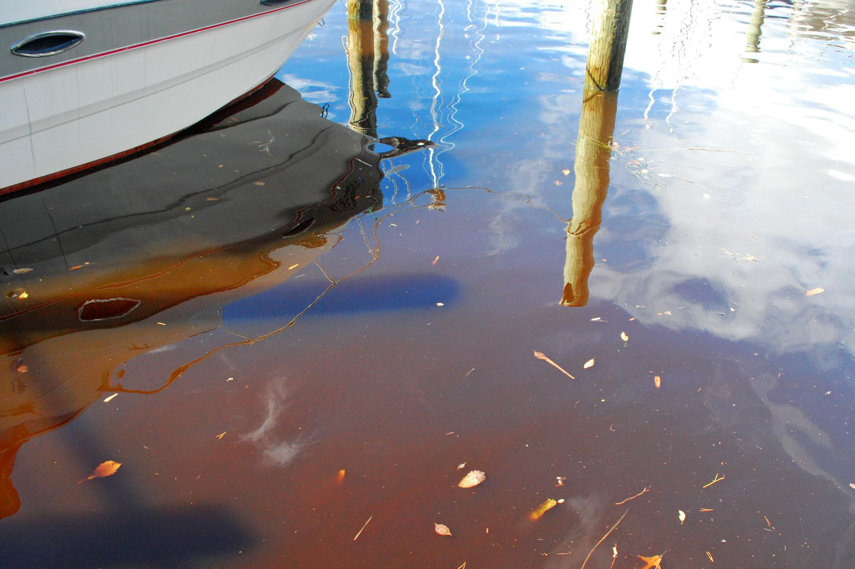
MDE reported Pocahontas Creek “contained a very large bloom with 104,040 cells per milliliter,” Maryland authorities consider a county of 10,000 cells to be worrisome and worthy of action. The sample also contained a species more toxic to fish and other water species, Karlodinium veneficum, finding 1,010 cells per milliliter. “A bloom of this biomass is something to watch,” the MDE report said. The Church Creek sample was worse — 113,686 cells of prorocentrum minimum and 1,616 of Karlodinium veneficum. MDE shellfish monitoring in the middle of the South River also found the two species. Though at lower levels they were concentrated enough to still constitute a bloom. The Maryland Department of Natural Resources has called Karlodinium the “fish killer” because it can produce five toxins. “Thankfully, no evidence of fish kills has surfaced on the South River so far,” Iliff said.

The blooms were noticed elsewhere. In the Severn River watershed the Severn River Association’s Tom Guay saw a heavy bloom in Chase Creek last week. “The waters are already murky,” he said. “This is so disappointing.”

Chesapeake Bay Foundation naturalist John Page Williams noted the NOAA buoy at the mouth of the Severn has reported blooms with seven chlorophyll spikes above 50 micrograms per liter in the past two weeks. He noted that the mahogany bloom is normal for this time of year, in May, but this is a particularly intense outbreak. On Thursday, Williams monitored an area of the river called the Winchester Lump. “It was fascinating to see what I interpret to be a bloom 20-feet deep,” Williams said. “I ran into a Natural Resources Police officer who told me he was seeing the bloom the full length of the river.”

Up on Meredith Creek near the Bay Bridge, other CBF staffers noticed Mahogany bloom last week but said it was worse two weeks ago. P. minimum tends to spike this time of year when rains wash excess nutrients into area waters, and the first warm days of the spring. According to DNR studies, May typically sees the highest number of mahogany outbreaks during the average year.
Scientific studies have noted the increase in algae blooms in recent years. The University of Maryland Center for Environmental Science underscored “more blooms, more often and lasting longer.” And not only in the Chesapeake Bay but worldwide. “In many places these trends are consistent with increased nitrogen levels,” said study author Pat Gilbert, a professor at UMCES Horn Point Laboratory. There are other sources of excess nutrients and not just from construction runoff, others note. This time of year homeowners are fertilizing lawns, and a rainstorm can wash excess nitrogen and phosphorus into creeks, rivers and the Chesapeake Bay. “There is enough nitrogen and phosphorus out there to keep these blooms fat and happy right now,” Williams said.
Florida’s Slimy Green Beaches
Large-scale harmful algal blooms (HABs) are becoming common on Florida coasts
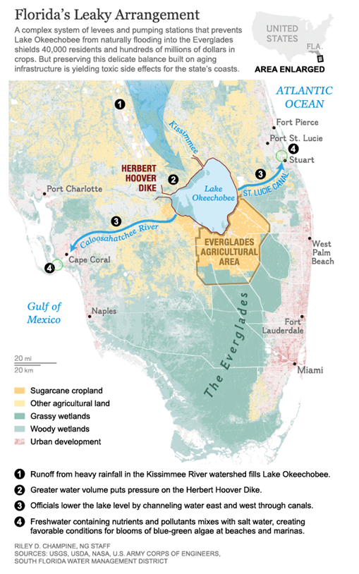
Ingredients:
Harmful algal blooms in Florida usually don’t originate in the ocean. They come from Lake Okeechobee. The lake absorbs agricultural runoff from cattle farms to the north and sugar cane fields to the south. This runoff is full of nutrients like nitrogen and phosphorous that fertilize the algae and nourish massive algal blooms. When heavy rainfall fills the lake with excess water, the only way to drain the lake and prevent flooding is to let the algal-rich water flow through rivers and canals towards Florida’s beaches. This creates favorable conditions for toxic algae blooms at the coasts.

Effect:
In 2013, the algal blooms in Florida were so bad, the event became known as Toxic Summer. In 2016, a HAB outbreak killed fish, shellfish, and at least one manatee. People who touched the sludge became sick. The blooms were so thick, they could be seen from space. State officials declared a state of emergency in four counties.
In the news:
National Geographic Story: Slimy Green Beaches May Be Florida's New Normal
https://news.nationalgeographic.com/2016/07/toxic-algae-florida-beaches-climate-swamp-environment
By Laura Parker. Published July 27, 2016

The green slime that washed onto Florida beaches earlier this month marks the eighth time since 2004 that toxic algae have fouled the Sunshine State’s storied coastline.
The algae blooms of 2013 were so severe the event became known as Toxic Summer. And this year’s outbreak has so thoroughly spread through delicate estuaries on both coasts that Florida officials declared a state of emergency in four counties. Toxic sludge has killed fish, shellfish, and at least one manatee and has sickened people who have touched it.
“This is absolutely the worst,” says Evan Miller, an environmental activist and founder of Citizens for Clean Water. Miller lives in the tourist town of Stuart, 110 miles (177 kilometers) north of Miami. “We’ve never seen algae so thick. You can see it from space. There are places in Stuart that are on their third and fourth cycle of blooms now.”

As the latest outbreak continues to play out with sporadic bursts of new algae blooms, dismayed Floridians are wondering if the recurring appearance of this tourist-repelling, fish-killing scum is their new normal. It may be.
Blue-green algae, also known as cyanobacteria, occur naturally and thrive in warm, calm water. Two conditions work against eradicating it: climate change and political inertia. ...
Florida, already confronting warmer and wetter days, will surely find itself battling more algae as the climate continues to heat up in the decades to come. But the guacamole-thick sludge that keeps appearing can be blamed more on political inaction. ...

Today, the lake is bordered by cattle farms to the north and sugar cane fields to the south, and it absorbs agricultural runoff from both directions. That helps make Okeechobee a perfect algae nursery. It is broad, shallow, and full of nitrogen and phosphorous—the kinds of nutrients that nourish massive algae blooms.

Lake Okeechobee is also a perfect launch pad for spreading green sludge to coastal beaches. The lake can gain two to three feet of rainfall during a normal wet season, and the only way to drain off excess water is to pump billions of gallons to both coasts through canals carved decades ago.
To get to the ocean, this algae-filled water must pass through the St. Lucie River Estuary and the Indian River Lagoon on the Atlantic coast and the Caloosahatchee River on the Gulf coast.
“They opened the gates and dumped it on us,” Miller says. “You could watch the algae moving down the canal.” …
Great Lakes Blooms
Harmful Algal Blooms (HABs) pose a risk to human and environmental health in the large freshwater Great Lakes.
Ingredients:
The Great Lakes have seen an increase in HABs since the mid-1990s. This phenomena is likely due to the elevated levels of phosphorus in the Great Lakes from urban and agricultural run-off, products containing phosphates, phosphorus and nitrogen in lawn fertilizer, and malfunctioning septic systems as presented in Figure 1.
Another contribution to the increase in HABs may be the invasion of zebra and quagga mussels. These mussels filter feed, eating non-toxic phytoplankton while releasing filtered toxic algae back into the ecosystem. A HAB in the Great Lakes may last several months and depends on the availability of sunlight, water and air temperature, bacteria levels, and water flow velocities [1].
Climate change may increase the frequency and severity of blooms due to rising water and air temperature along with reductions in winter ice cover in the Great Lakes. Additionally, climate change may increase the occurrence in severe spring storms. Rainfall washes runoff from agriculture into the water system which may contain high concentration of nitrogen.
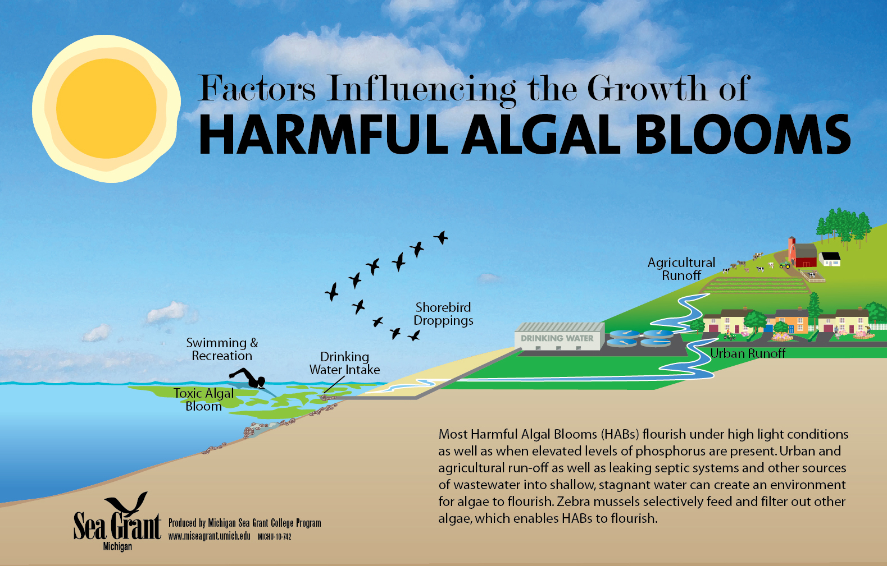
Figure 1: Schematic of factors influencing harmful algal bloom growth in the Great Lakes.

Effect:
HABs in the Great Lakes produce a wide variety of neurotoxins, cell toxins, liver toxins, and skin irritants. Consumptions of large amounts of these toxins by animals and humans can result in muscle cramps, nausea, vomiting, liver failure, etc. The most dominant form of HABs in the Great Lakes are Microcystis, a blue-green algae that produces Microcystin, a liver toxin and skin irritant.
Drinking water plants face challenges ensuring safe drinking water during extreme HAB events. Elevated temperatures over prolonged time periods, increase water usage, higher concentration of nitrogen and phosphorus from agricultural practices, and aging water treatment plant infrastructure increases the probability of toxins reaching consumer’s homes.

In the News: Predictions Come out for Lake Erie Algae Bloom in Summer 2018
http://www.news-herald.com/general-news/20180515/predictions-come-out-for-lake-erie-algae-bloom-in-summer-2018
By Richard Payerchin. Published May 15, 2018. Modified from The News-Herald on May 15, 2018

“Federal forecasters filed their first-of-the-spring harmful algal bloom projection for Lake Erie's western basin today, and the predictions for the summer are not optimistic.
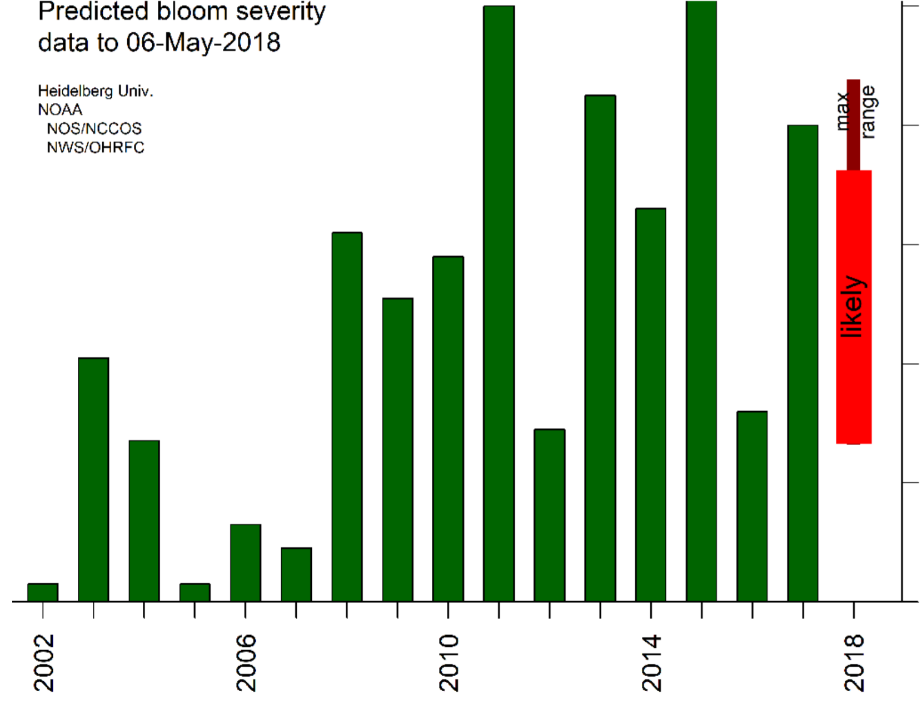
A wet early April combined with heavy rainfall last Wednesday produced slightly above average discharges of phosphorus runoff from the farm fields of Northwest Ohio into tributaries of the Maumee River, according to the National Oceanic and Atmospheric Administration.
Figure 2: Projected bloom compared to previous years. The wide bar is the likely range of severity based on data from the last 15 years. The narrow bar is the potential range of severity. Because the forecast uses modeled discharge for two months, there is a large uncertainty in bloom severity [3].
Phosphorus is primarily found in manure and fertilizer spread on the fields in spring, and is the primary source of algae-feeding nutrients to the lake's western basin.
Rainfall over the next several weeks is expected to be normal to slightly above normal, with a lower chance of major rainstorms that would cause significant additional runoff, the NOAA forecasters said.
The agency's prediction for the size of the algal bloom remains uncertain, ranging from slightly lower to significantly higher than last summer's bloom: the third largest on record, roughly the equivalent of the 2013 bloom, and trailing only the blooms of 2011 and 2015 in size.
"The phosphorus load to date is sufficient for some bloom to occur," the NOAA forecasters said in a prepared statement released this morning. " However, the uncertainty is quite large."
Lake temperatures and wind direction usually determine the spread of the bloom, the concentrations of harmful Microcystin bacteria and the date of the bloom's disappearance.”
References: [1]“Harmful Algal Blooms in the Great Lakes.” Michigan Sea Grant, 23 Feb. 2018. [2]Payerchin, Richard. “Predictions Come out for Lake Erie Algae Bloom in Summer 2018.” The News-Herald, 15 May 2018. [3]US Department of Commerce, and National Oceanic and Atmospheric Administration. Harmful Algal Blooms. 2018, oceanservice.noaa.gov/hazards/hab/.
“The Blob” West Coast Bloom
Large-scale harmful algal blooms (HABs) occurred off the West Coast during 2015.
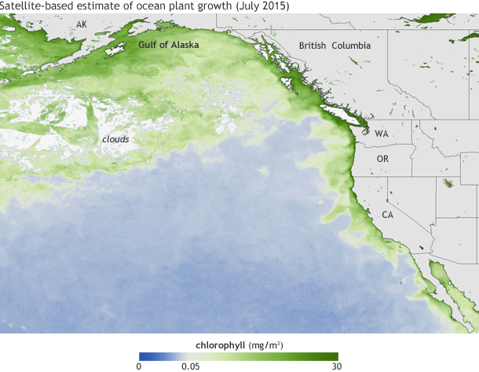
Ingredients:
High levels of toxic domoic acid were observed during a record-breaking Pseudo-nitzschia bloom, stretching from California to the Gulf of Alaska in 2015. Pseudo-nitzschia, a genus of phytoplankton, produces toxic domoic acid. There are many unknowns about why Pseudo-nitzschia algae succeed under stressful conditions (such as unusually warm or saline conditions) and outcompete other phytoplankton.
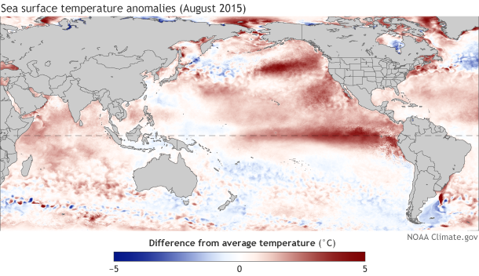
During the 2015 bloom, there was warmer-than-average ocean conditions in the tropical and North Pacific Ocean associated with the high levels of domoic acid in shellfish. The higher than average water temperatures started in 2013 when weak winds failed to mix and cool northeast Pacific Ocean allowing heat to accumulate and spread along the pacific coast until 2015. During this year, sea surface temperatures where up to five degrees higher than average, and at the bloom’s peak, 3.5 million square miles from Alaska to Mexico were warmer than average [1].

Figure 1: Concentrations of chlorophyll, a green pigment present in algae, in July 2015 (top). Differences in sea surface temperatures in August 2015 compared to the 1981-2010 average (bottom).

Effect:
The large-scale HAB resulted in deaths of many marine animals and closure of recreation and commercial fisheries in Washington, Oregon, and California. High levels of toxic domoic acid led to closures recreational razor clam harvests in the northwest and health advisories were issued to fisheries along the California coast. The death of >30 whales was attributed to the toxic bloom.
These closures were because digestion of domoic acid may pose to human life. The first human death from domoic acid poisoning was recorded in eastern Canada in 1987 when 100 people are contaminated mussels causing short-term memory loss and four deaths. “Amnesic shellfish poisoning” is a term for short-term memory loss experienced by humans exposed to high toxic levels. While this condition may be catastrophic to human life, the majority of people experience milder symptoms such as nausea and diarrhea [2].
In the news:
Oregon and Washington delay crab season because of toxin
https://www.seattletimes.com/seattle-news/washington-and-oregon-delay-crab-season-because-of-toxin
By The Seattle Time’s Associated Press. Published November 20, 2015

Oregon and Washington have joined California in delaying the start of their commercial crab seasons after dangerous toxin levels were found in the crabs.
Officials say elevated levels of domoic acid were found in crabs in all three states. The toxin is naturally produced by microscopic algae in the Pacific Ocean, but the massive bloom of algae caused by warming ocean conditions this year has led to more toxins produced and consumed by shellfish.

California had already delayed the Nov. 15 start of its season after finding dangerous levels of the toxin. Oregon on Friday delayed the Dec. 1 start along its entire coast, after testing in recent weeks showed higher toxin levels in the southern half of the state. Oregon Department of Fish and Wildlife officials said delay of the season will allow completion of additional testing to make sure toxin levels are safe. And in Washington, officials on Friday also said they’re delaying the season along parts of the coast where it starts on Dec. 1.

Tribal crab fisheries in Grays Harbor and the adjacent ocean area are open, and officials said the crab there is safe and toxin levels are lower. Crab seasons have been delayed in the past, but mostly because the crab were not full enough, said John Corbin, a fisherman whose company has two Dungeness crab boats in Warrenton, Oregon. Domoic acid has been found in crabs for decades, usually at very low concentrations that pose no risk, Corbin said. But elevated levels that are toxic to humans are only found every dozen years or so.

“This year they’re full enough, but we want to make sure the crab is good quality and safe for the public,” he said. “When things are right, we will go at it.”

Officials say crabs sold in stores and restaurants remain safe to eat. Some crab on the market now may have been harvested months ago and frozen for later, or sourced from other areas.
Domoic acid or amnesic shellfish toxin can cause minor to severe illness and even death. Cooking or freezing shellfish with high levels of the toxin does not destroy it and doesn’t make it safe to eat.

Because the toxin tends to accumulate in crab gut and in the fat inside the back of the shell, officials say even when the meat has been deemed safe people should remove all the fat and discard the gut before consuming the shellfish. Other shellfish affected by domoic acid include razor clams, which have been taken off menus in Oregon and Washington. Domoic acid has also been detected in mussels and oysters in the Puget Sound.

References: [1] “Scientists Link Toxic Algal Blooms along U.S. West Coast to Warm Waters in the Pacific | NOAA Climate.gov.” Global Warming Frequently Asked Questions | NOAA Climate.gov, 23 Jan. 2017. [2] Nicklen, Paul, and Tiffany Boothe. “The Blob That Cooked the Pacific.” National Geographic, 5 Apr. 2017.

Name ___________________________________________________________________________________________________
Date ___________________________________________________________________________________________________
Group Members __________________________________________________________________________________________

Expert Section
Your Case Study:

Notes:
Why did this bloom happen?

What were the repercussions?
Example discussion topics :
Name of Algae
Health Impacts
History of toxic events
Economic Impacts
Organisms Impacted
Impact of Climate Change

Group Member’s Case Studies:
Case Study:  Notes: | Case Study:  Notes:
Case Study:  Notes: | Case Study:  Notes:

Name:______________________
Teacher:_____________________
Class Period:_________________
Date:_______________________

Exit Slip
(please complete this worksheet before class ends)

- During class activities and group discussion today, which of the following did you try? (Check all that apply)
- I shared my ideas
- I listened to my partners’ ideas
- I agreed with my partners’ ideas
- I disagreed with my partners’ ideas
- I used scientific evidence to support my idea
- I asked a clarifying questions
- I could revoice my partners’ ideas
- My partners and I looked for similarities and differences in our ideas

- Explain one thing that you understand better or differently after talking with your partners today.

- What are two effects of harmful algal blooms on animals and/or humans?

- Pick two consequences of climate change and describe how they might impact harmful algal blooms.

