Storyboard: What to Expect

Module 1: Using LocalFood Core Values in Everyday Interactions
Learning Objective:
In your everyday customer interactions, drivers will have the confidence to apply the LocalFood core values: own it, above and beyond, and do the right thing. Effectively executing the LocalFood core values will have a direct impact on the customer’s experience and your overall driver service rating. A proficient rating is an average customer score of 4.5

Screen  101 | Title  Own It
Audio
Here at LocalFood our main purpose is serving our customers with quality service. However, as seen in the prior module (Navigating Unexpected Obstacles), there are things you will encounter that will be out of your control. When things don’t go as planned, it’s up to us as LocalFood team members to be present, hold ourselves accountable and do our best to resolve the issue. In this module, you will be presented with various choices in responding to customer’s frustrations. After you have selected the best choice, we will provide feedback before moving forward to the next core value.

Visuals/Screen Text
- 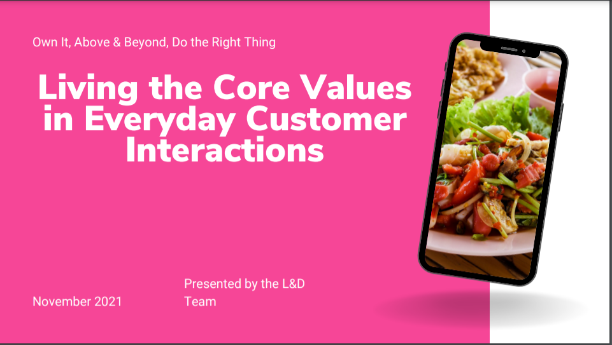
- 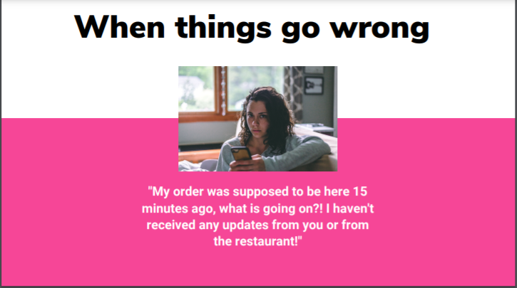
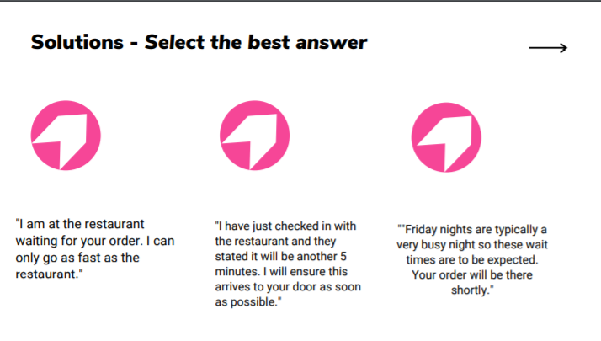

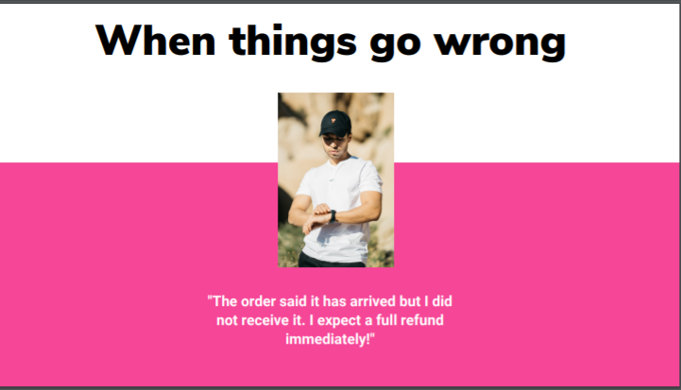
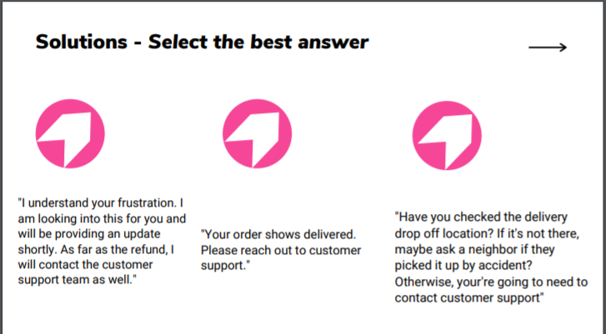
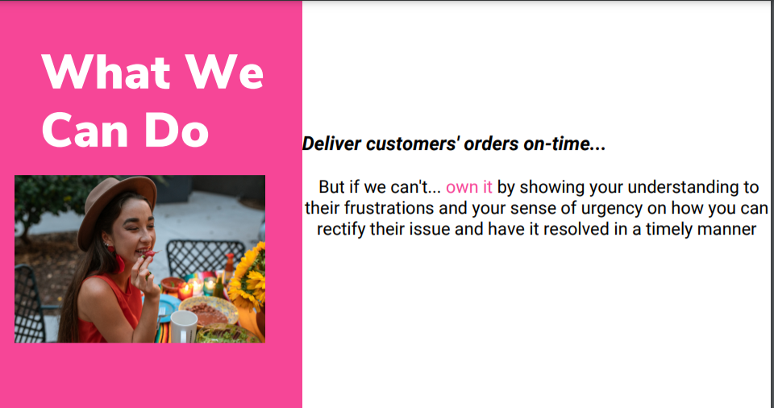

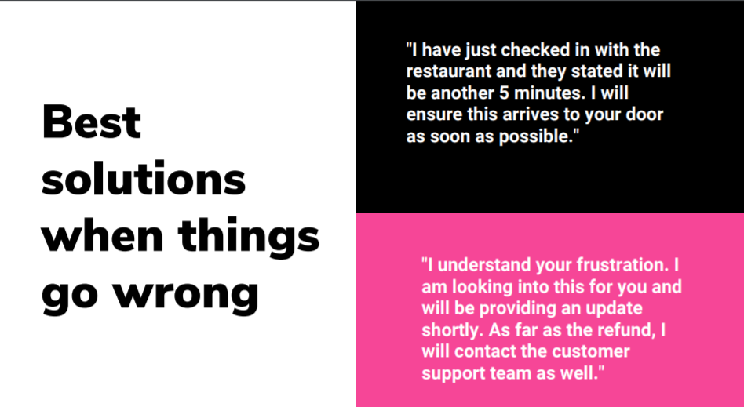
Programming
Next Button to Proceed to the next slide of the module : Screen 102

Screen  102 | Title  Above & Beyond
Audio
At LocalFood, we realize and understand that we would be nothing without our customers. Out of the handful of other food delivery platforms to choose from, they chose us. Hence, going above and beyond for them in ensuring we deliver their food safely and quickly while also giving them the best local restaurant options. This is the utmost importance to us and we take it to heart. In the next slides, you will have options on how to enhance your delivery service. Select the best option and we will provide feedback before moving on to our final core value.

Visuals/Screen Text
- 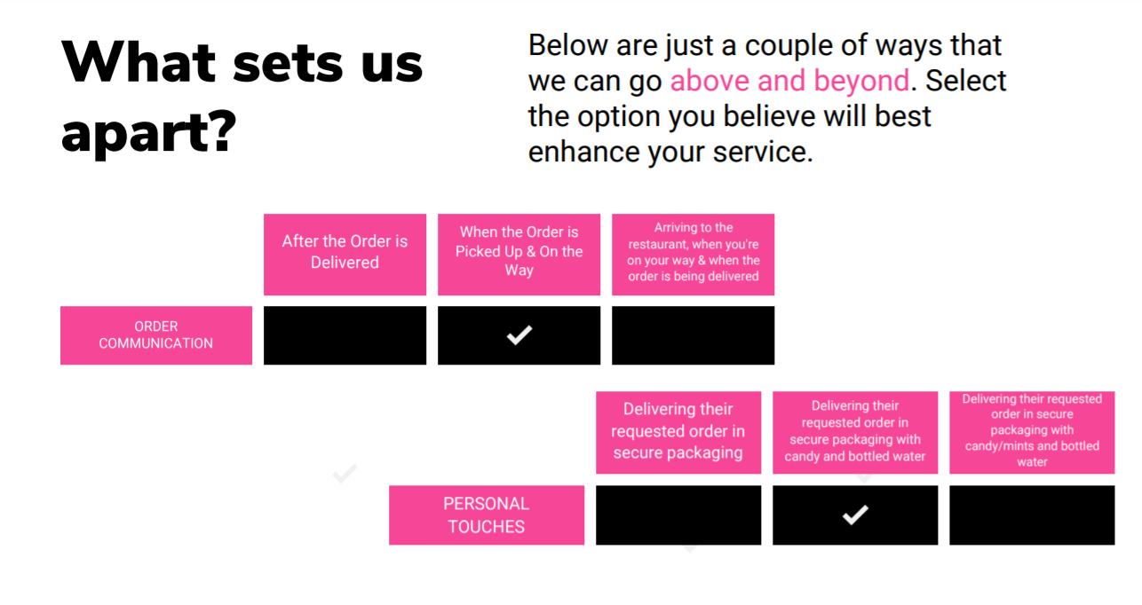
- 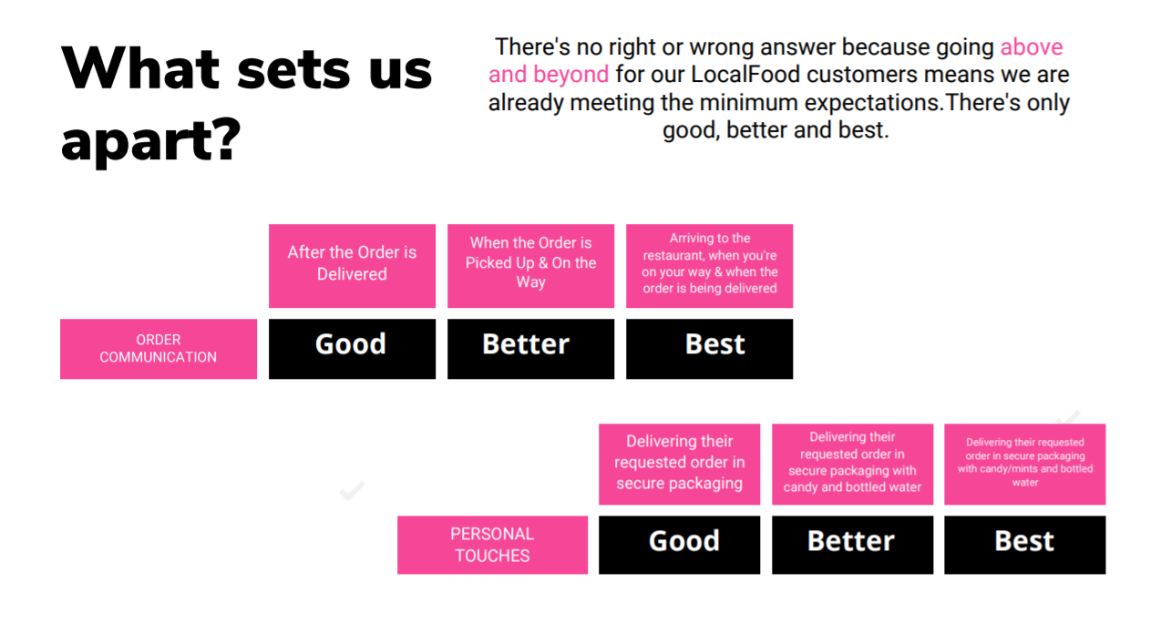

Programming
After selecting their best response for both categories, the box will be marked with a check mark on their selections. Next button appears after their selections to move to the next slide (good, better, best).

Screen  103 | Title  Do the Right Thing
Audio
Above all, as members of our communities and advocates for creating spaces for everyone, the meaning and purpose of LocalFood is doing the right thing. The testing is over – in the final slides you will hear from some of our most personable, considerable and highly performing service LocalFood drivers as well as our Executive Management Team.

Visuals/Screen Text
- 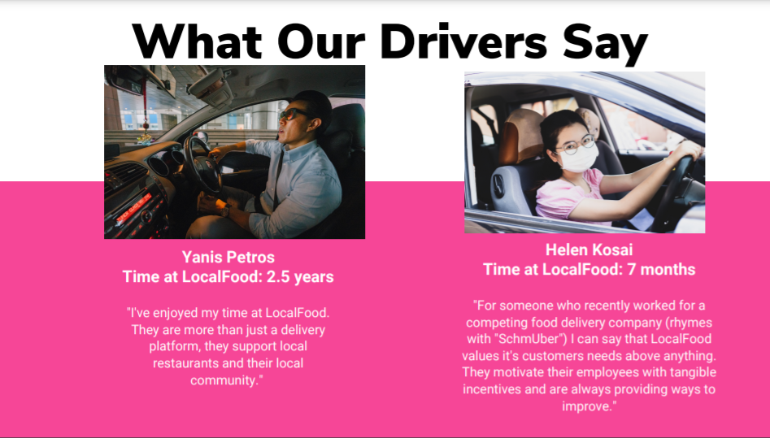
- 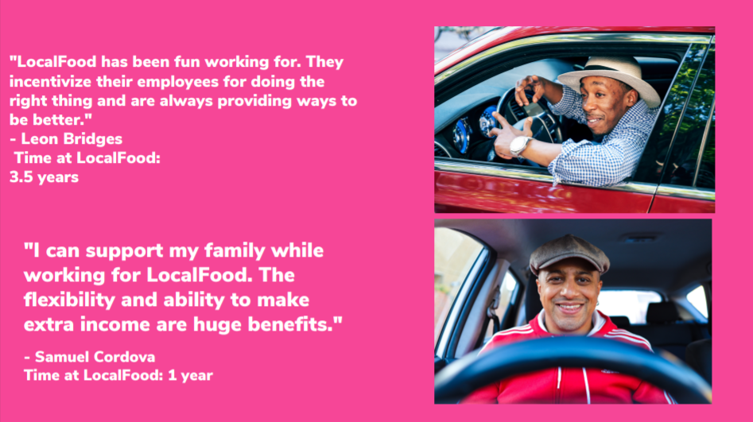

- 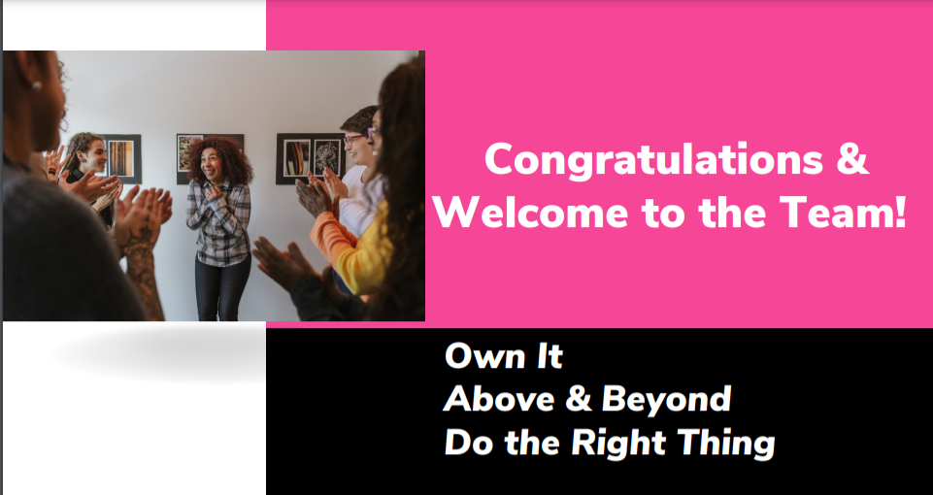
Programming
A button to complete the course will appear at the bottom of slide “Congratulations”.

